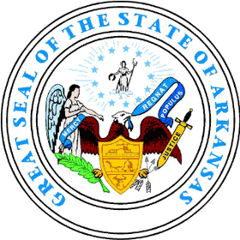  MIKE BEEBE  GOVERNOR | STATE OF ARKANSAS  DEPARTMENT OF EMERGENCY MANAGEMENT  Tornado Drill Reporting Form | 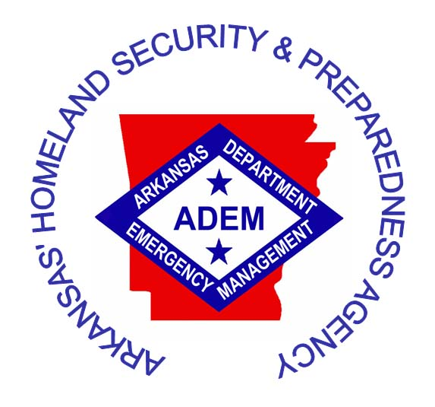  DAVID MAXWELL  DIRECTOR
SCHOOL NAME:_________________________________________________________

ADDRESS:______________________________________________________________

CITY:__________________________ STATE:____________________ ZIP: ________

RECORD OF TORNADO DRILLS
MONTH | DATE/YEAR | TIME | # EVAC | NOTES
SEPTEMBER
OCTOBER
JANUARY
FEBRUARY

Arkansas Code Title 6, Chapter 10, Subchapter 121. Tornado Safety Drills
(a) (1) As used in this section, “public school” means a school that is part of a public school district under the control and management of a local school district board of directors.
(2) “Public school” includes the Arkansas School for Mathematics, Sciences, and the Arts, the Arkansas School for the Deaf, the Arkansas School for the Blind, and juvenile detention centers.
(b) It shall be the duty of the Director of the Arkansas Department of Emergency Management to require all public schools to conduct tornado safety drills not less than four (4) times per year in the months of September, October, January, and February.
Instructions

Please complete this form when you accomplish required drills and maintain a copy of completed forms in your permanent records.

