
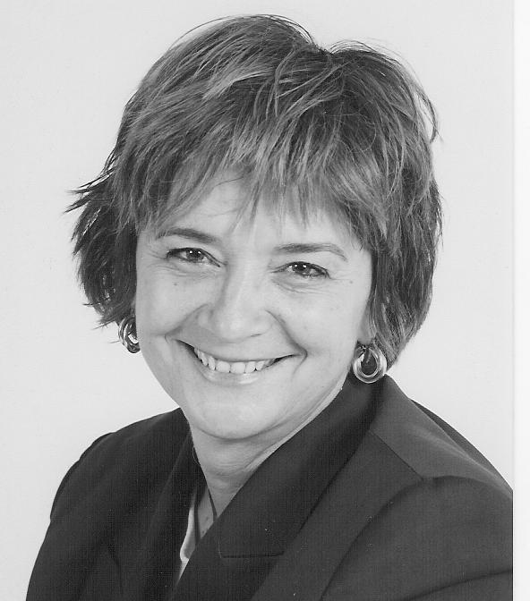

PRESENTS

The Seventh Annual
Best Practices Educators’ Forum:
Achieving Educational Excellence through the Arts

Featuring

Dr. Heidi Hayes Jacobs


Why do you need to be there?
- Without curricular alignment on the district level, learning gaps occur impeding student growth and achievement.

- Where curriculum is well defined and presented, teachers are free to tap into ways of teaching to fully engage students.

- Integrating arts experiences into the core curriculum increases student academic performance.

What this forum is.
- Opportunity to hear & talk with an expert in the field of education.
- Opportunity to interact with colleagues who share your passion.
- Opportunity to acquire new strategies and develop engaging, and rigorous arts curriculum.
Who needs to be there?
- District and campus leaders, administrators, lead teachers, school board members…any stakeholder in education.
Limited Space! Call Sara or Sue at 903/792-8681 if you need more information!!!
- President of Curriculum Designers, Inc., has served as education consultant to thousands of schools and prominent arts organizations nationally and internationally.
- Best selling author of Interdisciplinary Curriculum: Design and Implementation, Mapping the Big Picture: Integrating Curriculum and Assessment K-12 and newly released Getting Results with Curriculum Mapping. Dr. Jacobs is also the author of numerous journal articles.
- Consultant for Kennedy Center, NYC Ballet, Carnegie Hall, NBC Sunday Today Show, Children’s Television Workshop, ASCD, The Discovery Channel, the Peace Corps, the Disney Company, the Near East School Association based in Athens, Greece, International Baccalaureate, the European Council of International Schools, and state education departments.

Wednesday, December 15th, 2004 8:30 a.m. to 3:00 p.m. Cost $30 (Materials Included/Lunch on Own)
at the Beautiful, Historic Perot Theatre (3rd and Main, Downtown Texarkana)

The ArtsSmart Institute for Learning is a program of the Texarkana Regional Arts and Humanities Council, Inc. It is made possible in part by grants from the US Department of Education, Texas Commission on the Arts, the Arkansas Arts Council—an Agency of the Department of Arkansas Heritage, the National Endowment for the Arts, the generosity of TRAHC members and by the commitment to education excellence made by members of the Board of Trustees and participating ArtsSmart Campuses.

Best Practices Forum
Registration
December 15, 2004

The ArtsSmart Institute for Learning will host the Seventh Annual Best Practices Educators’ Forum in Texarkana, Texas, on Wednesday, December 15, 2004, at the historic Perot Theatre. The forum will meet from 8:30 to 3:00 p.m. The Perot Theatre is located at 219 Main Street (on the corner of 3rd and Main) in Downtown Texarkana. Please reserve your space by returning the reply form below before December 1, 2004 (We cannot guarantee materials or space if you reply after December 1st). A block of rooms has been reserved at the Four Points Sheraton, located at 5301 N. State Line Ave. (on the corner of State Line Ave. and I-30) for $65.00 per night. For reservations, call (903) 792-3222 by December 1st and request a room reserved for the TRAHC Best Practices Forum. The hotel is less than 10 minutes from the Perot Theatre (maps to the Perot will be available at the hotel).

Reservations are required for guaranteed seating at the forum. Attendees will receive an e-mail confirmation memo from the ArtsSmart Institute for Learning as acceptance (please complete the form below for this purpose—all fields are required for registration.) Registration and packet pick-up will take place at the Perot Theatre between 8:00 AM – 8:30 AM on December 15th.

Individualized invoices will be provided to attendees with their registration materials on the day of the forum (please complete the form below for this purpose). If the attendee has prepaid, a receipt confirming payment will be provided in the place of an invoice.

You must fax or mail the reply form below to the ArtsSmart Institute for Learning office in order to guarantee space and materials at the forum. You will receive an e-mail confirmation notice. If you do not receive a confirmation by e-mail or have questions regarding the meeting, please contact Sara Lawrence at (903) 792-8681 or e-mail: slawrence@trahc.org
***************************************************************************
7th Annual Best Practices Educators’ Forum Registration:

Name______________________________________________________ Title___________________________________________________________

School/Organization Representing______________________________________________________________________________________________

Phone_____________________________ Fax____________________________________ E-mail_______________________________________

Address__________________________________________________City__________________________________State_________________Zip_________

PAYMENT (please check one): Bill me the $30 registration fee Payment is included Code ASC04

**Please fax a reply by December 1, 2004 to the ArtsSmart Institute for Learning (903) 793-8510 FAX.

