Correction Process
The excel file contains three worksheets:
- Enter Corrections Here---This is a worksheet with column names and blank rows. This is the worksheet for entering the corrected information. LEA’s will enter only the information that needs to be corrected, not the information that is already correct in the MISMATCH_LIT, MISMATCH_MATH, NOMATCH_LIT OR NOMATCH_MATH data sets. When the corrections are completed, this is the worksheet that will be sent to the ADE for review of the requested corrections.

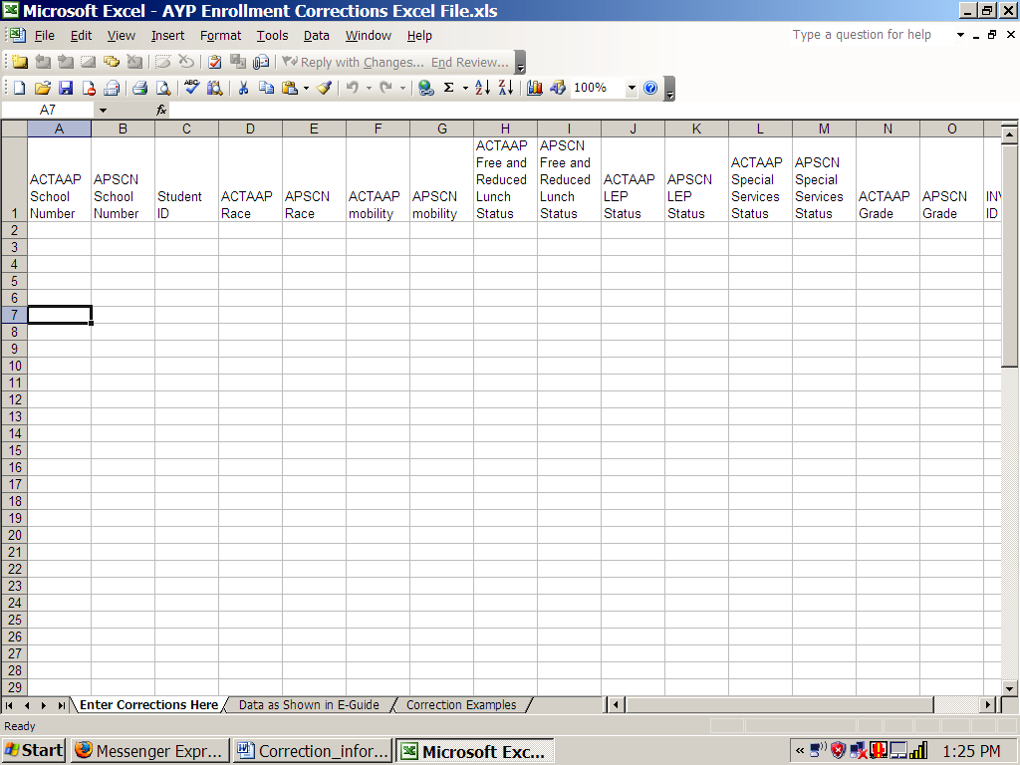

- Data as Shown in E-Guide—This worksheet is an example of how the data currently looks in E-Guide. This is not a school specific example. The data in this worksheet is an example of the information provided in MISMATCH_LIT, MISMATCH_MATH, NOMATCH_LIT OR NOMATCH_MATH.

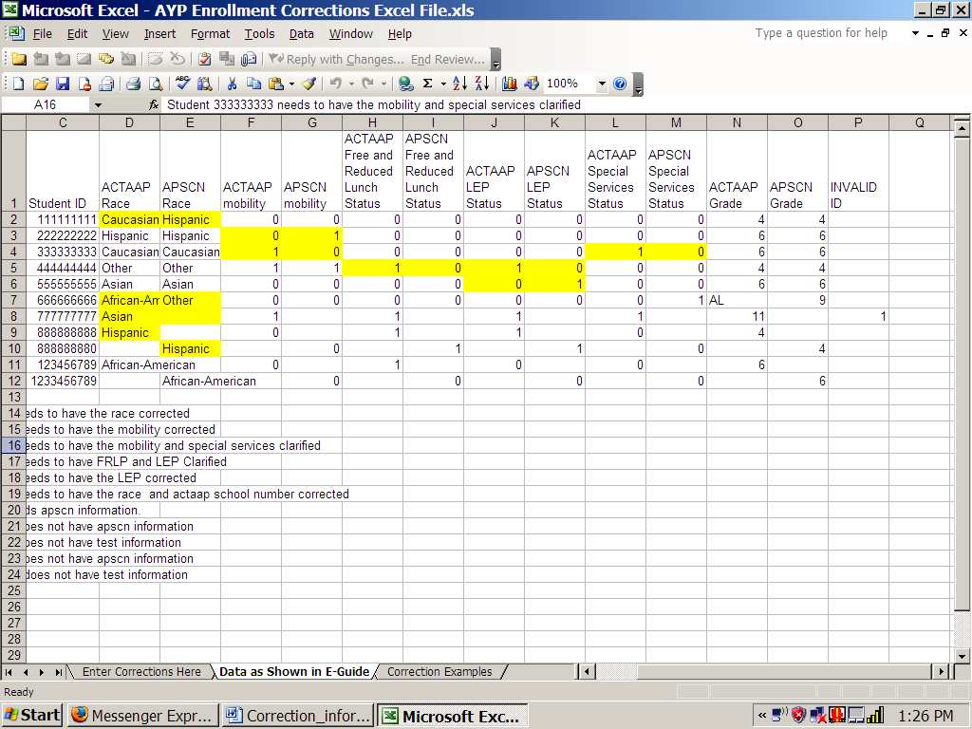
Note that all the data is shown in EGuide—correct and incorrect.

- Correction Examples—This worksheet demonstrates what an LEA corrected worksheet will look like when it is submitted to the ADE for review. Note-- in the “Corrections Example”, only the data that needs to be changed is included in the worksheet, not the original data that was already correct. This is how the data corrections should be entered in the “Enter Corrections Here” worksheet.

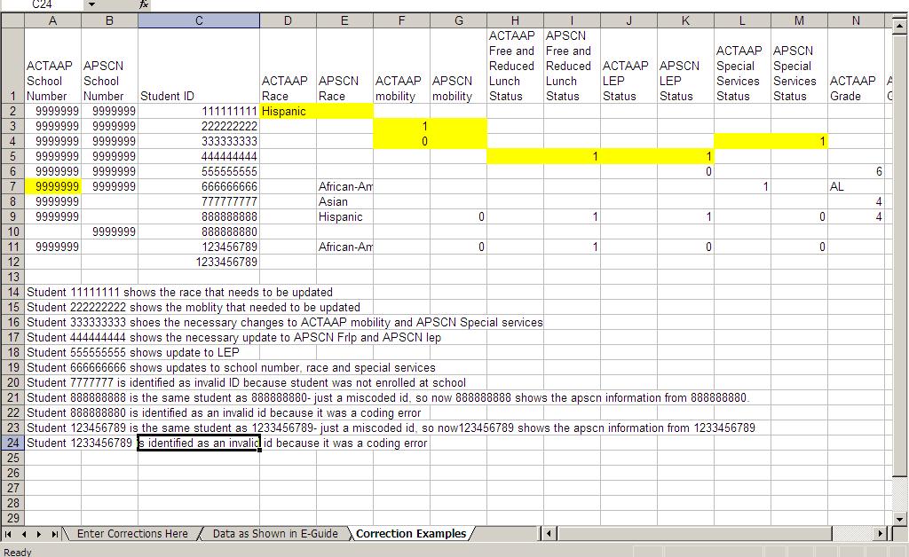
This is how corrected data should be entered in the blank sheet named “Enter Corrections Here”. The corrected data is the only data that should be entered. This example shows that correct data in the E-Guide MISMATCH_MATH, MISMATCH_LIT, NOMATCH_MATH, or NOMATCH_LIT are not re-entered here, but left blank in the cell. Important Note: Only corrections are entered for submission to ADE. for review.

When the LEA has completed the corrections, the Excel file is forwarded to Janinne Riggs along with any necessary supporting documentation no later than ten (10) working days from the date of the Commissioner’s Communication.

Janinne Riggs, Special Assistant to Commissioner
Arkansas Department of Education
#4 Capitol Mall, Rm 406 B
Little Rock, AR 72201

