Note: Be certain to fill in the LEA number and contact information in the upper left corner of the Report

Page 1 of Act 28 Report Worksheet

- Total Fund Balance – All Sources of Funds
Enter balances from Board Report (Finance Plus> Reports >Fund Accounting >Custom Reports>Board Report).

Run report with following criteria (After all fiscal year 2007 transactions have been posted)
Fund Selection = [123458]*
Starting Period =1
Ending Period =13
Year = 2007
Print Section 1 Only – check box
Click OK
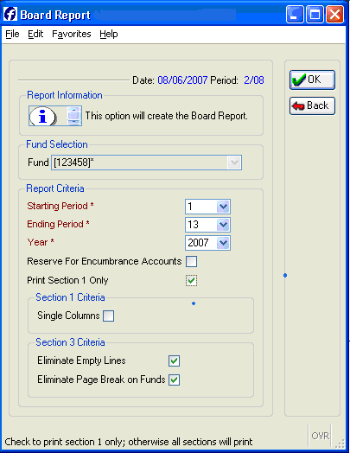

Enter the “Ending Balance” amount from Board Report for total fund amounts for Fund 1, 2, 3, 4, 5 and 8 to “Total Fund Balance – All Sources of Funds” row. The report worksheet will total all funds in the last column. This worksheet row should equal your Board Report’s total Ending Balance.

2. Restricted Funds Included in Fund Balance
Enter “Fund/SOF” ending balance amounts from Board Report in the "Restricted Funds Included in Fund Balance” row for each restricted SOF for funds 1, 2, 3, 4, 5 and 8. The report will total all SOF amounts in the last column. If there are restricted balances other than what are identified with the source of fund codes listed on the spreadsheet identify those restricted funds on page 2, line 8, under “reasons for maintaining, instead of spending, the Unrestricted Legal Balance.”

3. Bal Sheet 01915
Print consolidated balance sheet for Deposits-Paying Agents (QZAB) as follows:

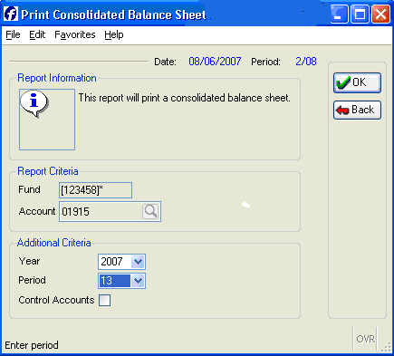

Enter fund amount from Consolidated Balance Sheet to “Bal Sheet 01915” line.

The worksheet will total each fund row listing Total Restricted and Total Unrestricted balances based on information entered in above steps # 1, 2 and 3.

4. Encumbrances
Enter total amount of “Next Year PO Encumbrances” (FY 08) by fund as of June 30, 2007. If encumbrance amount as of June 30, 2007, is unknown then leave blank.

Page 2 of Act 28 Report

5. Transfers Between Funds
Run Cognos Report:
Log in Cognos 8 from APSCN web site http://www.k12.ar.us/

Select ADE APSCN – Financial Management System folder

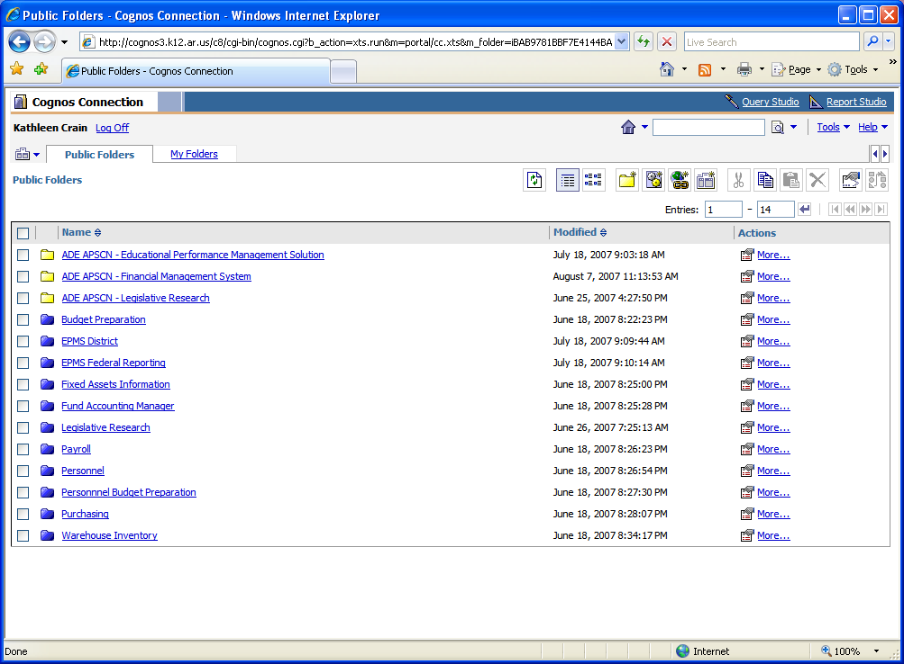

Select Fund Accounting Manager folder and
Go to last page

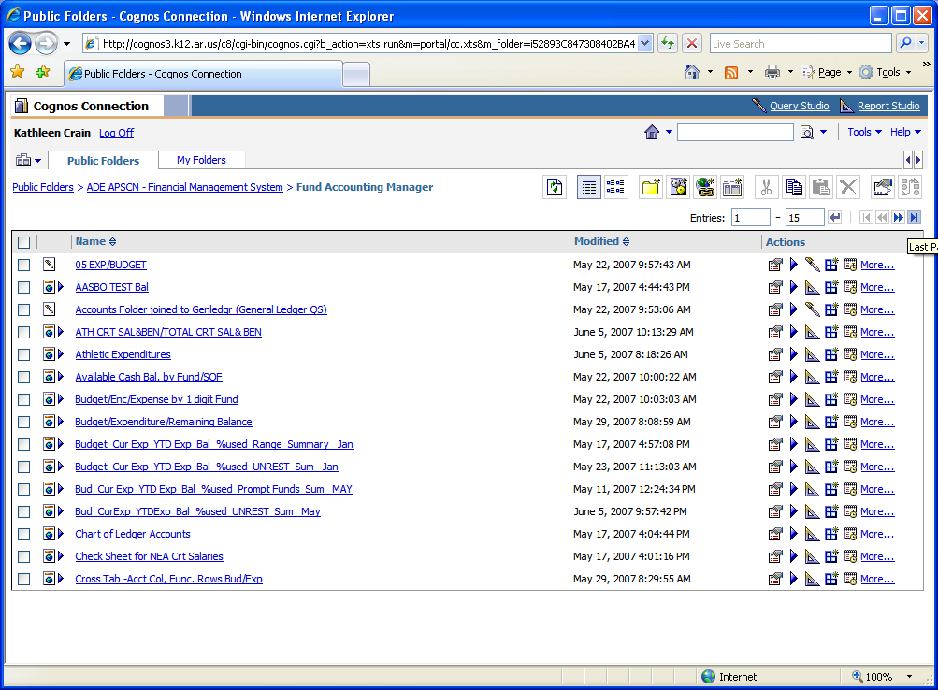

Click on “Transfers” to run the report:

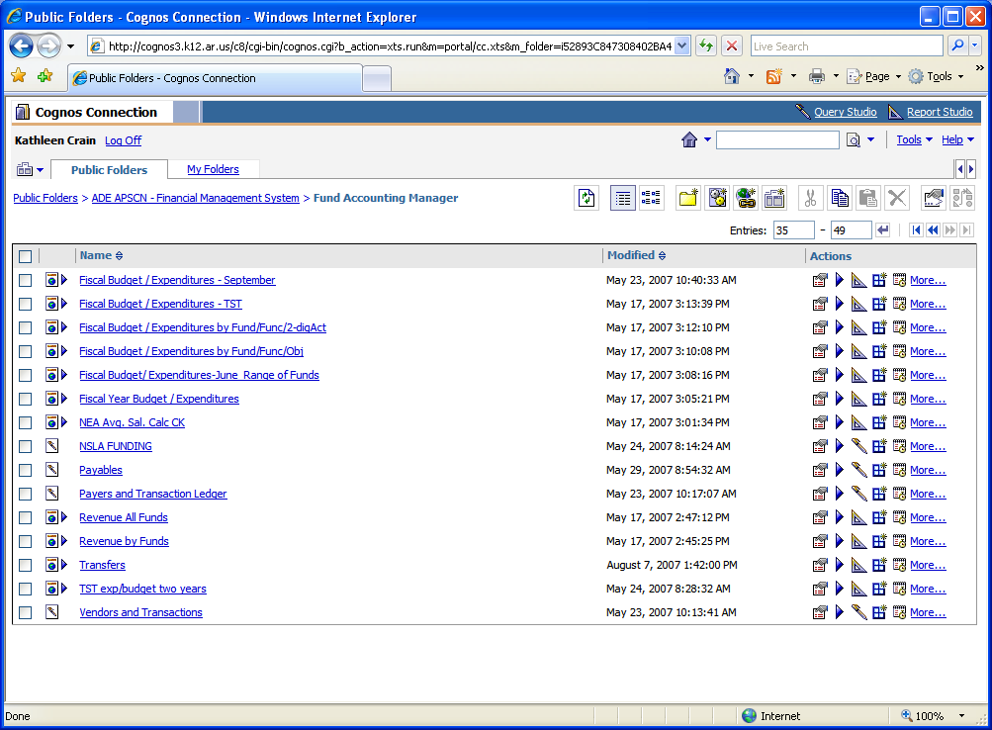
Report will prompt you to select Fiscal Year. Select FY 07 and Click FINISH

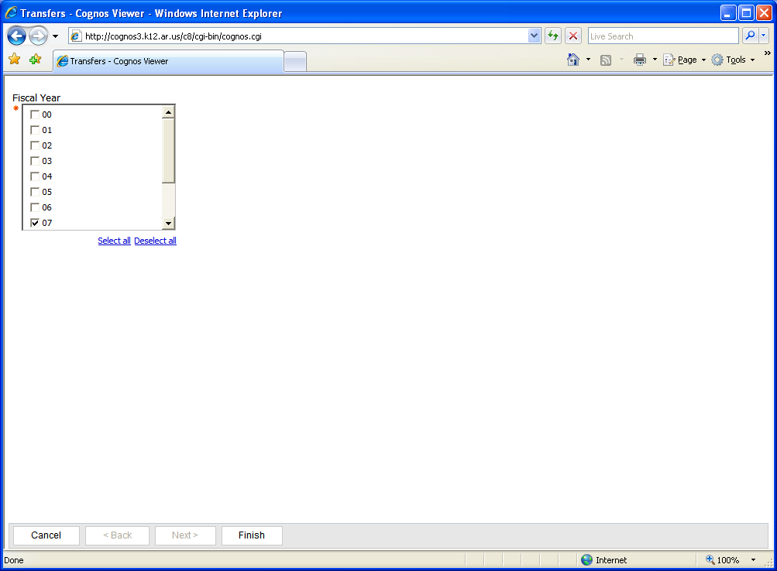

Report will display.
Click the Printer Icon and select Print.

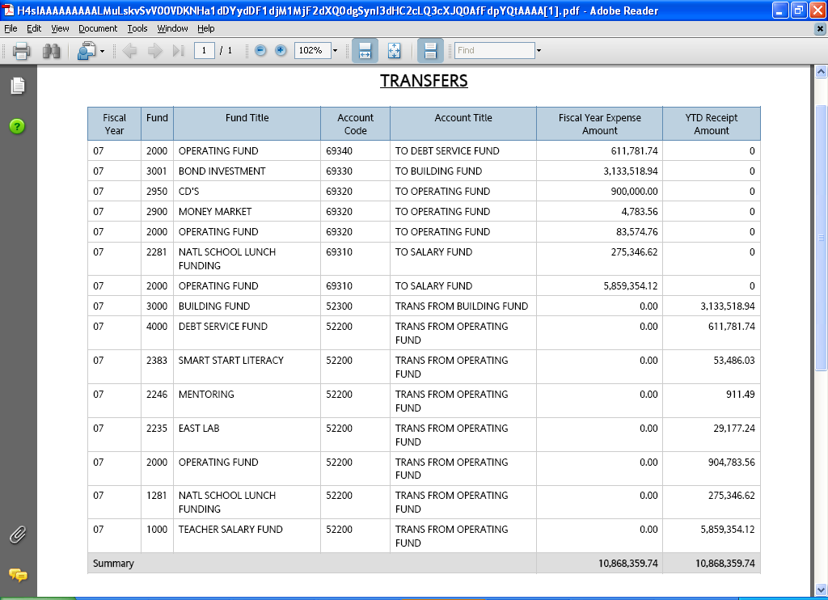

Note: Exp. Amt. column (transfers out) should equal Receipt Amt. column (transfers in).

For “Transfers between Funds” (page 2 of the Act 28 excel worksheet), please remit this Cognos report with Act 28 spreadsheet.

6. Legal Balance-Unrestricted
Amounts will populate from data entered on Page #1 of worksheet based on formula.

7. Total Expenditures-Funds 1, 2 & 4

A. Fund – 1

Enter the Total Teacher Salary Fund “Expenditures” amount from the Board Report to the “All Expenditures” line on spreadsheet.

B. Fund – 2 & 4

Print the Summary Expenditure Status Report (Reports>Fund Accounting>Financial Statements>Expenditure Status Reports>Summary expenditures Status Report) for Fund 2 and 4.

The summary expenditure status report for each fund should be run as follows:

Fund 2, Account - 61000:69299
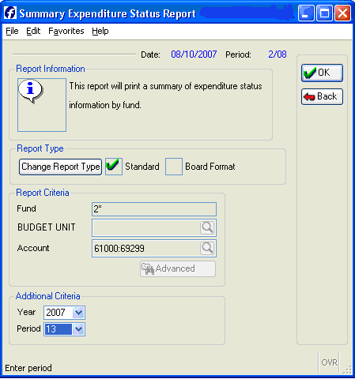

Fund – 2, Account - 69400:69999
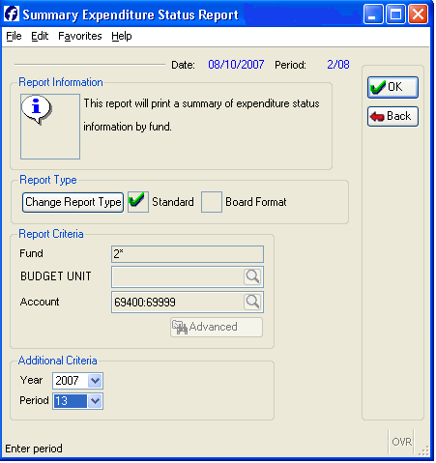

Fund – 4, Account – 61000:69299
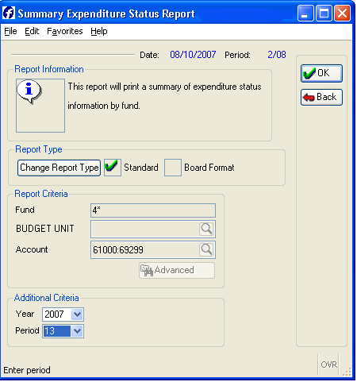

Fund – 4, Account – 69400:69999
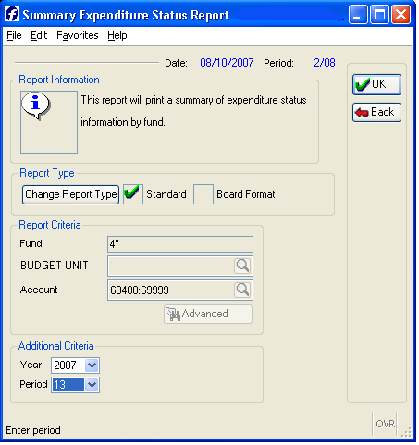

Add Fund 2, 61000:69299 and 69400:69999 reports together and enter on “All Expenditures” line.

Add Fund 4, 61000:69299 and 69400:69999 reports together and enter on “All Expenditures” line.

The worksheet will total the expenditures columns.

The “Total Unrestricted Legal Balance as a Percent of Annual Expenditures will populate based on the formula, Total Unrestricted Legal Balance /Total All Expenditures.

8. Reasons for Maintaining, Instead of Spending, the Unrestricted Legal Balance
Give detailed explanation of unrestricted balances.

Page 3 of Act 28 Report

9. Reasons for Maintaining, Instead of Spending, the following Restricted Fund Balance
The “Balance in Funds 1 & 2” for each SOF will populate from data entered on page #1. Enter categorical fund revenue received in “Annual Revenue” column for each SOF. If the “Balance as Percent of Annual Revenue” populates to more than 25% then provide a detailed explanation of unspent restricted fund balances.

Page 4 of Act 28 Report

10. Amount of Fund Balances Dedicated for the Construction, Maintenance, or Repair of Academic or Athletic Facilities
The “Fund/SOF” amounts and “Total” amount will populate from data entered on page #1.

After worksheet has been completed send all of the following to:
APSCN
Attn: Jill Davidson
101 East Capitol, Suite 101
Little Rock, AR 72201

- Act 28 of 2006 completed Excel Worksheet
- 2007 Board Report (Periods 1 through 13, 2007)
- Cognos “Transfers” Report

Questions regarding help with the instructions or completion of worksheet should be directed to APSCN financial field support or APSCN FMS Help Desk at 1-800-435-7989 or 501-682-HELP (4357).

