EAST Vision Building Summary

- What: The EAST Project Vision Building Workshop
- When: November 15, 2007, 9:00 am - 12:00 pm
- Where: Lecture Hall, Campus Center
Pulaski Technical College
3000 West Scenic Drive, North Little Rock, AR 72118
- Who Needs to Attend: A local school team (5-7 people are recommended) comprised of:

      - A District Level Administrator (someone who can sign for obligations and financial awards)
      - A Building Level Administrator
      - A representative for the classroom teachers
      - A representative for the staff that schedules classes (counselors or registrars)
      - Other interested community representatives (parents, school board members, interested members of the business community, district technology staff, curriculum coordinators, etc.)
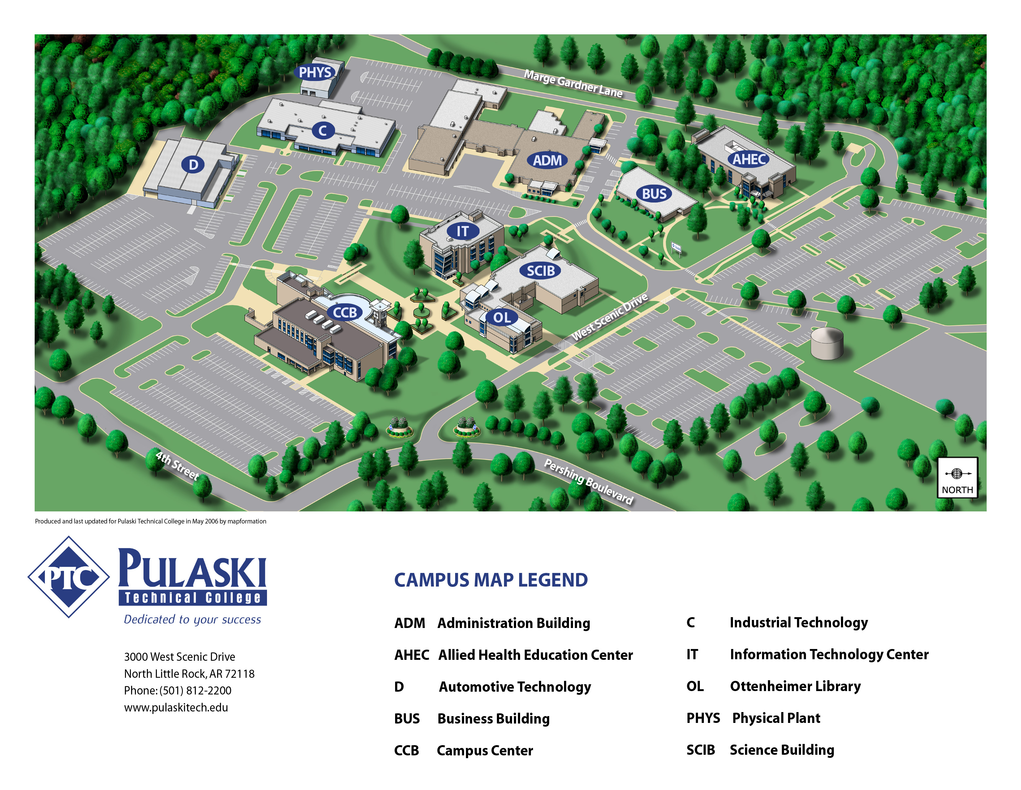

To Pulaski Technical College:


