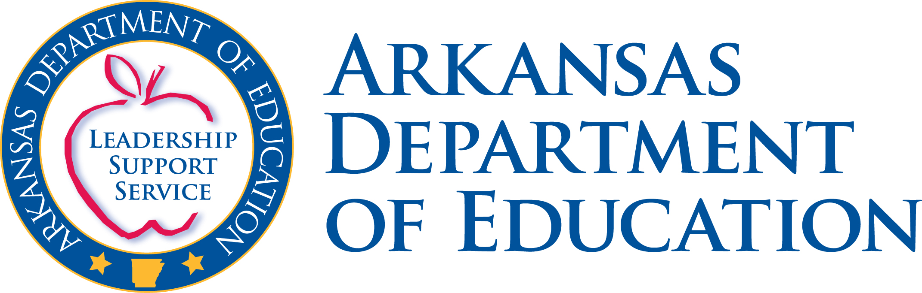

2009 H1N1 Flu (SWINE Flu) – Education Related Issues

Will a school close if a person in the community is diagnosed with H1N1 (SWINE) flu?

The Arkansas Department of Health Director has authority under Ark. Code Ann. § 20-7-109 to close public and private schools, so this decision will be made by the Arkansas Department of Health, in consultation with school officials and the Arkansas Department of Education (ADE). A decision will be made according to what is deemed most appropriate for the health and welfare of the students and the community.

If schools are not closed, what precautions should be taken at the school?

Schools should remain vigilant for the possible occurrence of H1N1 (SWINE) flu in the school populations. According to the Arkansas Department of Health, students or staff who exhibit flu-like symptoms (sneezing, coughing, headache, body aches and possibly vomiting and/or diarrhea) and have a fever of 100 degrees or more should be instructed to go home and call a physician. All individuals at the school should observe “healthy” behaviors such as frequent and adequate hand-washing, using tissues when coughing or sneezing, avoiding hugging, kissing or touching persons who exhibit flu-like symptoms. For more information, link to http://www.HealthyArkansas.com

What will happen if I take my children out of school even if the schools do not close?

This is a parent’s decision. However, please be aware of attendance policies that dictate when credit is lost due to excessive absences as this can prohibit a student’s advancement to the next grade. Typically, this occurs when there are absences of more than 10 days.

How long will schools remain closed?

This decision will be made by the Arkansas Department of Health in consultation with school officials and the Arkansas Department of Education. A decision will be made according to what is deemed most appropriate for the health and welfare of the students and the community.

Will schools have to make up days missed because of H1N1 (SWINE) flu?

Arkansas statute mandates 178 instructional days of six hours each, so the answer to this is yes. As this situation evolves, the Arkansas Department of Education may elect to grant waivers. If that happens, decisions regarding waivers will be made on a case-by-case basis.

If my child’s school is closed, can I enroll the student into another school?

Enrolling a child in another school is not recommended as it could enable the spread of H1N1 (SWINE) flu.

Can we home school while the school is closed?

It is beneficial for school work to be continued during a closing of a school. According to the Arkansas Department of Health’s “State Plans to Enable Community Mitigation through Student Dismissal and School Closure,” students should take school books and assignments home with them and, when possible, educators should maintain contact via the Web. However, it is understood that not all students or faculty will have access to computers and/or the Internet once away from the school building.

Parents may opt to officially enroll the students in home school, but the enrollment requirements may make it impractical to do so. The provisions of Ark. Code Ann. § 6-15-503 must be complied with:

(a)(1) Parents or guardians desiring to provide a home school for their children must give written notice to the superintendent of their local school district of their intent to provide a home school for their children and sign a waiver acknowledging that the State of Arkansas is not liable for the education of their children during the time that the parents choose to home school:
(A) At the beginning of each school year but no later than August 15;
(B) By December 15 for parents who decide to start home schooling at the beginning of the spring semester; or
(C) Subject to the provisions of subsection (d) of this section, fourteen (14) calendar days prior to withdrawing the children from the local school district and at the beginning of each school year thereafter. The superintendent or the local school board of directors may waive the fourteen-day waiting period.

What happens if a school is closed during the Advanced Placement testing period?
AP Coordinators, in conjunction with the schools’ leadership, are responsible for determining whether the school closing or illness would make the late-testing date preferable. If so, AP Coordinators should order alternate exams for late testing through the Web at http://www.collegeboard.com/school . Any alternate testing that has been necessitated by H1N1 (SWINE) flu will not incur the $40 alternate exam fee. Coordinators should select “Emergency: Serious injury, illness, or family tragedy” or “School closing: natural disaster” as a reason for late testing to avoid that surcharge. The alternate exams will replace the already ordered exams, which schools should send back unopened. There will NOT be an unused exam fee for those already ordered exams that would have been given on the regularly-scheduled dates. Alternate exams are offered from May 20-22.
The deadlines for ordering alternate exams are:
- International Schools: May 8
- Schools in the U.S and U.S. territories: May 15
If H1N1 (SWINE) flu-related issues extend beyond the alternate testing period, and/or if issues arise that make it impossible for students or schools to test during the late-testing period, the school may contact AP Services to arrange for exception (or “alternate-alternate”) testing. The exams occur after the alternate exam window according to a schedule determined by AP Services. Exception forms are only offered in extreme circumstances, only after schools have availed themselves of the regularly-scheduled and late-testing exam options. [School closing is an acceptable reason for exception testing.]

Schools that have issues with both the regular and alternate testing windows, who wish to order exams for exception testing, must call AP Services at 877-274-6474 or 609-771-7300 to place orders for exception exams. The $40 surcharge will not be charged to schools requiring exception forms due to swine flu emergencies or other natural disasters. [Note: Exams designed for use during the first late-testing period may not be used on the later dates. Schools must use the exception form that is ordered through AP Services.]

What happens if a closed school is the site of an administration of SAT?

Regarding the SAT, the closed school site is to call 1-800-257-5123 to report that the facility will be closed. Then SAT staff will begin to contact students and post the information on the Web site with specific instructions regarding taking the exam: http://www.collegeboard.com/student/testing/sat/testday The College Board will keep the site updated. In the event that Internet access is not available, inquiries may also be directed to: US toll-free: 866-756-7346 and Outside US: 001-212-713-7789.

What happens if a school is closed during the Algebra II End of Course test?
This will be decided on a case by case basis. The Algebra II Consortium’s window for administering the test extends late into the school year, so in many scenarios it will be possible for the school to administer the test at a later date.

Will extracurricular activities occur – school plays, graduation ceremonies, etc.
This decision will be made by the Arkansas Department of Health in consultation with the school district but once a school has closed, it is not recommended that students congregate elsewhere when the school has been closed.

To give students something to do while out of school, is it okay to tell parents they can organize sports or parties, if the children are not symptomatic?

It will be best for children to remain at home and not in contact with others
because of the possibility of continuing to spread the flu.

If one school in a district is closed, will there still be school bus service?

This is a school district decision that should be made in consultation with the Arkansas Department of Health.

