CAREER DEVELOPMENT CONFERENCE
Co-sponsored by Arkansas Department of Career Education (ACE) & Arkansas Department of Education (ADE)
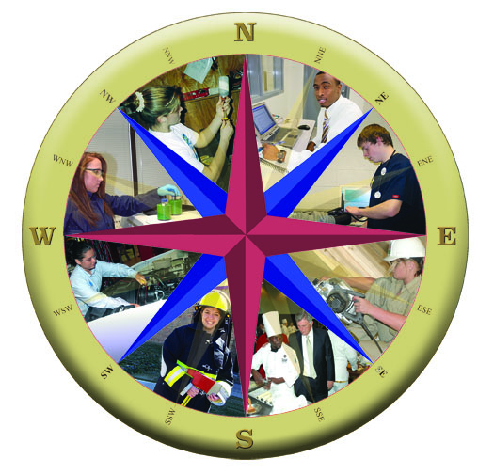
Navigate Your Future – With a Career Plan

March 14 -16, 2010

Best Western Inn of the Ozarks
1-800-998-9620, www.innoftheozarks.com
207 West Van Buren, Eureka Springs, AR 72632

REGISTRATION (Fee $70)

Name Title
School/Agency District
School/Agency Address
City State Zip
Work Phone ( ) Home Phone ( )
Cell Phone ( ) Home E-Mail
Fax ( ) Work E-Mail

Enclose a check in the amount of $70 for registration, dinner on Sunday and Monday evening, and breakfast buffet on Monday and Tuesday. Registration deadline is March 1, 2010. Late registration or registration at the door does not guarantee meals.

Make check payable to Career Development Conference and mail with completed registration form to:
Arkansas Department of Education
Guidance and Counseling Unit
Four Capitol Mall, Room 202-B
Little Rock, AR 72201

Contact Liz Francoeur at (501) 371-2696 or e-mail Liz.Francoeur@Arkansas.gov for additional information.
CAREER DEVELOPMENT CONFERENCE
NAVIGATE YOUR FUTURE – With a Career Plan
March 14 – 16, 2010
Best Western Inn of the Ozarks, Eureka Springs

Target Audience: K-12 School Counselors, Career Coaches/Career Development Facilitators, School Kuder Administrators, and CAP Chairs/Committee Members

Conference Objectives: To provide current and relevant information to assist educators in counseling and advising students in planning for a career. Participants will share expertise and gain knowledge that is vital to educating the whole student.

Conference Focus: New! Arkansas Works Information Arkansas Programs of Study
New! Kuder Navigator System Training Galaxy Training (Elementary)
Career Planning & Development Programs Career Clusters and Pathways
College and Career Planning Programs Labor Market Information
Career Development Models & Resources Employability Skills
Classroom Career Activities Military Career Opportunities
Career Development Portfolios Perkins IV Funds
Role of Tech Centers Apprenticeship Programs
Arkansas Career Readiness Certificate KeyTrain

Conference Schedule: Check in registration for the conference will be from 3:30 – 5:00 p.m. on Sunday, March 14 with dinner at 5:00 p.m. and Sunday’s sessions ending at 8:30 p.m. Registration will begin again on Monday at 7:00 a.m. to 12:30 p.m. with breakfast from 7:00 – 8:00 a.m. Monday’s morning sessions will end at 12:30 p.m. with lunch on your own and time to enjoy the exhibits and Eureka Springs. Monday’s evening programs will begin at 5:00 p.m. with dinner. Sessions will end at 8:30 p.m. Tuesday will begin with breakfast at 7:00 a.m. and the conference will conclude 12:30 p.m.

Registration: Deadline to Register is March 1. (Number of Participants will be limited due to space) Complete attached registration form and submit a check in the amount of $70.00 (includes registration, dinner on Sunday and Monday evenings, and breakfast on Monday and Tuesday).

Make check payable to Career Development Conference and mail to: Arkansas Department of Education, Guidance & Counseling Unit, Four Capitol Mall, Room 202-B, Little Rock, AR 72201

Lodging: Best Western Inn of the Ozarks at (479) 253-9768 or 800-998-9620,
Standard Room rate $59.00

Contact Liz Francoeur (501) 371-2696, liz.francoeur@arkansas.gov
Information: Betty Ruth Welch (501) 682-4354, betty.welch@arkansas.gov
Ray Henson (501) 682-1616, raymond.henson@arkansas.gov
Roger Palmer (501) 682-5144, roger.palmer@arkansas.gov

